Students will have multiple opportunities to demonstrate proficiency
Major assignments (unit assessments, culminating events etc…) will constitute 30% of your child’s grade. Minor assignments (daily classwork) will constitute 70% of your child’s grade.
Grade 3
This year your child is able to make up any classwork assignment that they wish due to a grade they may like to improve. Assignments that are NOT allowed to be redone include:
- Math unit assessments
- ELA culminating events
- Science, social studies, and health unit assessments
Your child will need to complete a “Redo Form” and have it approved by their teacher in order to resubmit the assignment. Please see an example of this form below.
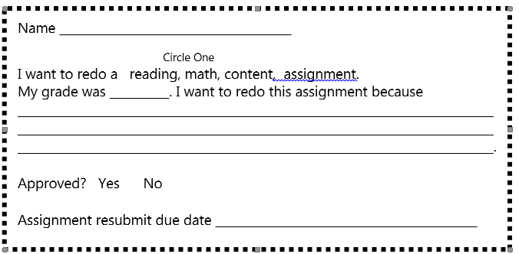

Grade 4
On English Language Arts tasks students are typically provided numerous focused writing tasks and ongoing feedback throughout the writing process before submitting a final written product. Students are asked to produce writing for Language Arts Culminating Events. These Events are NOT eligible for a Re-Do, however, students may re-do short writing assignments leading up to the events and they may Re-Do through revision, writing tasks leading to the culminating event until it is submitted for evaluation
In grade 4, tasks which are eligible for Re-Do/Revision will be due no later than one week past the initial posted grade. It is expected that students complete Re-Do’s during the school day at a time agreed upon by the teacher unless it is agreed that the assignment may go home.
On math tasks, Periodic Assessments and Unit Assessments are NOT eligible for Re-Do because they are intended to summarize a students’ ongoing work and practice with targeted standards.
- Students in grade 4 must turn in Re-Do’s no later than one week past the initial due date. It is expected that students complete Re-Do’s during the school day at a time agreed upon by the teacher unless it is agreed that the assignment may go home.
Grade 5

Students can request up to 2 opportunities to redo most assignments (summative assessments cannot be redone).
- Redo requests must be submitted in writing and made within 1 week of the original grade being posted.
- If a student scores higher on the redo, he/she will receive the higher grade.
- If the student scores lower on the redo, the scores between the original and new grade will be averaged together.

